REVIEW GUIDE
CHAPTER FOUR: THE NORTHWEST TO 1870

Important People, Groups, and Events
Outline the importance, achievements, or significance of the following:
1. The Hudson’s Bay Company

The Hudson’s bay Company was a fur trading company that established posts around Hudson’s Bay and owned Rupert’s Land. It traded goods to First Peoples who brought in furs, a policy called ‘stay by the bay’. The HBC was run from London, England. Employees in the colony did not share the company’s profits. The HBC shipped furs to Britain and imported goods for trade. Students should refer back the chart listing the advantages and disadvantages of working for the HBC vs. the NWC.
2. The North West Company

The North West was an aggressive fur trading company. It was run out of Montreal but built posts inland to simplify trade with First Peoples. The NWC was based on partnerships; all members shared the company’s profits. Furs were transported back to Montreal and were shipped to Britain during the summer months.
3. The Métis
The Metis were a group of people of both European (usually French-speaking) and First Peoples ancestry who lived in the Northwest. Many Metis settled in the Red River Valley. Metis hunted in the Red River Valley. Metis hunted bison for meat and clothing. The bison hunt also fostered a strong sense of community, pride, & discipline.

4. Lord Selkirk

Lord Selkirk, a director of the HBC, wanted to develop a farming colony in theRed River Valley. Unemployed immigrants from Scotland could settle and work in this area. The HBC gave him this land. The colony ran into trouble because Selkirk did not give any thought to the Metis who already lived there, or to the harsh climate that made agriculture difficult.

5. Miles Macdonell

Miles Macdonell was an ex-militia officer who led a group of labourers and their families to the Red River Valley to set up a colony. Because the first year's crops were poor and his colony faced starvation, he issued the Pemmican Proclamation in 1812, that banned the sale and export of pemmican from the Red River Valley. This action infuriated the Metis and the North West Company because both relied heavily upon the pemmican trade. Macdonell also ordered the NWC to vacate the area.
7 Colin Robertson

Colin Robertson was a HBC trader who made peace with the Metis and NWC, and was able to re-establish a colony in the Red River Valley.
8. Robert Semple

Robert Semple was the new governor of the Selkirk colony. In a show of force, he attacked a NWC post, and convinced the Metis that the colonists intended to make war with them. Semple was the leader for the colonists in the battle of 7 Oakes.
9. Cuthbert Grant

Cuthbert Grant was a well-educated leader and employee of the NWC. He led a group of Metis on a raid and seized a supply of pemmican from the HBC. The group viewed this as reasonable compensation for what they had lost because of the Pemmican Proclamation. Grant would lead the Metis and NWC men against semple and the colonists in the battle of 7 Oakes

10. The Battle of Seven Oaks

The Battle of Seven Oaks was a skirmish that pitted the NWC and Metis against the HBC and the new colonists. Robert Semple's men were outmaneuvered by the Metis (led by Cuthbert Grant); twenty of his men were killed.

11. George Simpson

George Simpson, a "hands-on" businessman, was put in charge of the HBC and its territory. Although he traveled constantly throughout his territory; he became a social outcast because of his unkind and autocratic ways and because his wife, Frances, refused to socialize with the Metis.

12. The Orange Order

The Orange Order was a Protestant movement that was violently anti-French and anti-Catholic. Members of the Order were prejudiced against the Metis. They viewed the Metis as inferior because of the bicultural heritage of this group.

13. John Schultz

John Schultz arrived in the Red River Settlement in 1860. He took over the only newspaper in the settlement, the Norwester, and published anti-Metis articles. He also organized a small group of anti-Metis supporters into the Canadian Party, which he hoped would eventually gain control of the settlement. These actions led to further tension with the Metis.

14. Louis Riel

Louis Riel was a well-educated lawyer and an excellent orator. He assumed leadership of the Metis in 1868. He formed the Metis National Committee to fight for Metis concerns about the land. He was worried that the Canadian government was trying to take away Metis land. To prevent this, he seized munitions from a fort, set up a provisional government, and drew up a List of Rights to protect Metis rights.

15. Thomas Scott

Thomas Scott was the most belligerent member of the Canadian Party. He loudly publicized his anti-Metis views, and threatened the life of Louis Riel. He was executed by Riel's government and became a Protestant martyr for the racist Orange Order.

16. Colonel Wolseley

Colonel Wolseley was ordered by the Prime Minister to lead a force of 1200 troops, and maintain peace until a provincial government could be set up in the Red River Valley region.

Main Ideas and Concepts
1. What impact did the fur trade have on the First Peoples in the Northwest?
- First Peoples were encouraged to trade furs to the HBC and NWC in exchange for goods.
- As fur-bearing animals became scarce, groups of First Peoples moved from their original territories into the lands of other groups.
- Fur trading disrupted the traditional way of life. As First Peoples tried to keep up with the companies' demands for fur, they had to abandon their yearly cycle of fishing, hunting, and preserving food.
- Contact with Europeans exposed First Peoples to deadly diseases, such as measles and smallpox.
2. Discuss the origins and development of the Métis.
- As NWC traders began pushing into the Northwest, they began wintering in First Peoples' trading areas and staying with local groups. Quite often, fur traders married Native women.
- Generations later, descendents of these unions developed a distinct culture. They called themselves the Metis; spoke either the French and Algonquian languages or a mixture of the two; and they were usually Roman Catholic.
- By 1810, a large number of Metis lived in the Red River Valley, where they developed agriculture using the French system, and also hunted bison, which was a tradition of the Plains group.
3. Describe the Red River Settlement of 1821—1860 under the following headings:
• Population -- In 1821, the population was evenly divided between the Metis and countryborn (non-French, European-Native descendents,) and the European settlers. By the end of the period, more than 80 per cent of the population was of mixed descent. The birth rate was high; families often had more than ten children. As a result, the population grew dramatically from the 1840s on.
• Economy/ business -- The economy was organized around the needs of the HBC. Scottish settlers grew many crops and sold these to the HBC. The Metis supplied pemmican and other goods acquired from the bison hunt to settlers and the HBC. The HBC controlled trade until 1849 when its monopoly was broken. It was a self-sufficient community, relying solely upon its own resources
• Society --The country-born were typically white-collar (clerks, teachers, magistrates, store owners,) and saw themselves as superior to the Metis. The colony was socially isolated. Residents had a small-town mentality: if someone behaved improperly, the news spread quickly; people were often tempted to gossip about their neighbours.
• The role of women--They helped in the grain harvest. They processed the wool in the community: cleaning, carding, and spinning it. At night, they had to prepare bannock (flatbread) for the next day's meals. Women also gave birth to and raised up to fifteen children.
4. What major changes took place in the Red River Settlement between 1860 and 1870?
- Arrival of Canadians, most of whom were Protestant and members of the Orange Order, looking for new areas to settle and farm;
- Economic problems, such as failing crops, depleting bison numbers, and loss of interest of the HBC;
- Canada becoming a dominion-the government was interested in obtaining land from "sea to sea";
- And the decline of the HBC meant that the company could not effectively govern its territory. It sold Rupert's Land, which included the Red River Valley area, to the Canadian government.
5. Outline the major events that shaped the Red River Rebellion.
- The settlers were angry at many groups, including:
  - The HBC for proceeding with the sale of Rupert's Land without consulting them, and
  - The land surveyors who were laying out square townships in the summer of 1869 with no regard for the traditional strip lots of the Metis.
- Louis Riel formed the Metis National Committee to fight for Metis concerns about their land. Metis actions included the following:
  - They met with Governor McDougall and told him to go back to Ottawa because they were going to govern themselves.
  - They occupied Fort Garry and seized its munitions.
  - Riel set up a provisional government to maintain order and to negotiate an agreement with the government to allow the Red River Settlement to join Confederation as a new province in December 1869.
  - The Metis drew up the List of Rights and the Charter of Rights and Freedoms.
  - Riel led a party of armed Metis to John Schultz's home, the headquarters of the Canadian Party, and captured Schultz and forty-eight of his followers.
- In March 1870, Riel's government executed Thomas Scott, a member of the Canadian Party.
- The government agreed to the terms for Manitoba's admission into Confederation, and granted 200,000 hectares of land for the Metis in April 1870.
Comprehension
1. Compare/ contrast at least 3 differences in company policies/ structure between the HBC and the NWC.

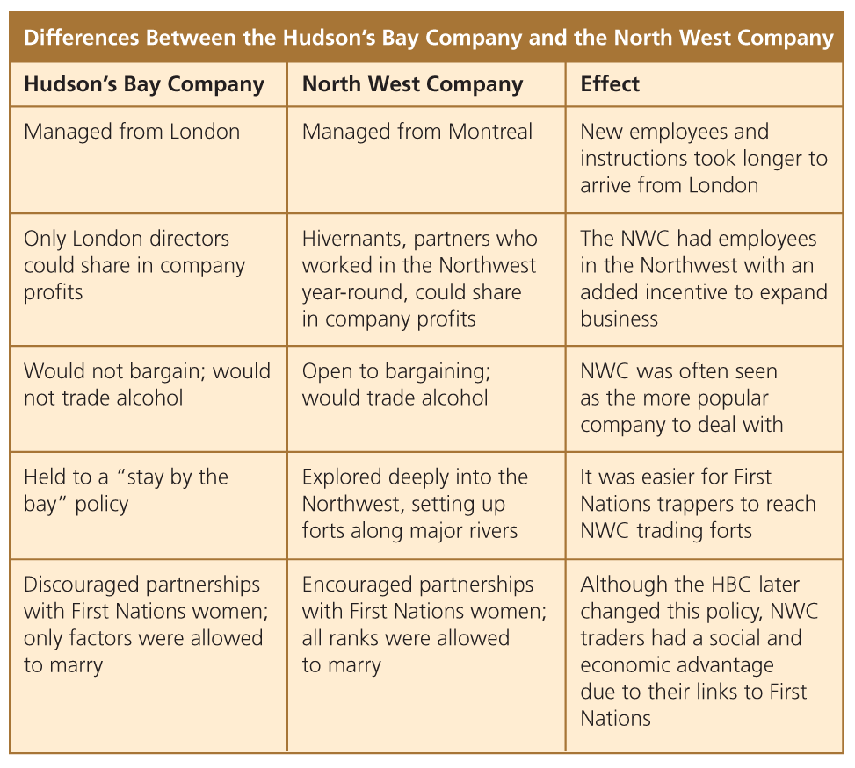
3. What was the effect of European diseases on the First Peoples of the Northwest?
- Natives were less immune to diseases, such as smallpox and measles, that Europeans brought with them. A small pox outbreak killed off much of the region, Chipewyan and Cree populations.

4. Explain the Metis Bison Hunt: (Who, what, why, how). Be able to explain the meaning/purpose of at least 2 rules of the bison hunt.
Refer to pages 140-142 of Horizons.

5. a) Why did Lord Selkirk wish to establish an agricultural colony?
- Lord Selkirk wanted to establish an agricultural colony for farmers, called "crofters," who had been evicted from their land in Scotland. He learned that the Red River Valley was especially fertile. He asked for and was granted this land by the HBC.
b) What facts did he overlook when he decided to establish such a colony in the Red River Valley area?
- Lord Selkirk overlooked the fact that the Metis had already been living in this region for decades. He did not consider how they might react to an influx of farming colonists. He also overlooked the difficult climate of the region, which was much harsher than Scotland's climate.

6. In point form, explain the conflict between the following people:
a) Miles Macdonell and the Métis
- Macdonell issued the Pemmican Proclamation, which banned the sale and export of pemmican, because he feared the colony would run out of food.
- The Metis were infuriated because they relied heavily on the pemmican trade with the NWC.
- Macdonell ordered NWC employees to vacate all their posts in the Red River Valley.
- The Metis and the NWC, led by Duncan Cameron, retaliated by harassing the colonists by burning buildings, trampling crops, and firing rifles at night. The Metis arrested Macdonell and took him to Fort William for trial.

b) Robert Semple and the Métis
- Semple attacked and burned a then empty NWC fort.
- A group of Metis, led by Cuthbert Grant, raided a brigade of HBC boats, and seized a supply of pemmican.
- Both parties clashed at the Battle of Seven Oaks. All twenty-eight of the colony's troops, as well as Semple, were killed in the skirmish.
7. How did Lord Selkirk react to the defeat at the Battle of the Seven Oaks?
- Lord Selkirk was furious. He moved west with mercenary troops, seized Fort William, marched on the Red River Settlement, took over military control of the area, and, for the third time, tried to set up a colony.
8. Why did the HBC and the NWC merge in 1821? What were the terms of the merger?
- The HBC and the NWC merged in order to survive; there were not enough furs in the Northwest to justify full-scale operations by both companies.
- Terms of the merger included:
  - To be referred to as HBC
  - HBC routes would be used
  - The NWC partners would control 55 out of 100 shares; the HBC partners would control the remaining 45.
  - The new company would still control Rupert's Land and enjoy, like the old HBC, a trading monopoly.
9. What were the main provisions outlined in the Métis List of Rights?
- The right to elect their own legislature;
- The power to pass laws that had been vetoed by the federal government;
- The right to elect officers, judges and school commissioners.
- The right to a free homestead using the traditional land system
- The persevering portions of the land for use for schools, bridges, roads & public buildings
- The demand for a federal government promise that a railway would be constructed between the Red River Settlement & Winnipeg.
- The demand for the federal government to pay military, civil, and municipal expenses for four years;
- The demand that the military be made up only of Red River people;
- The right to use French and English languages in court and for all public documents;
- The demand for judges to speak both the French and English languages;
- The demand for the federal government to ratify treaties with First Peoples;
- And the demand for the Red River people to have full representation in the Canadian Parliament.

10. What things did the government do in the aftermath of the Rebellion?
- Agreed to the terms for Manitoba's admission into Confederation;
- Did not allow provincial control over public lands, but did give the Metis 200 000 hectares of land, in recognition of their Aboriginal title;
- Dispatched 1200 troops to Winnipeg to keep the peace until a transfer of power to a new provincial government could be made;
- Granted all members of the provisional government amnesty; and banished Louis Riel from Canada for five years.

